**SCTR’s Pune Institute of Computer Technology Dhankawadi, Pune**

# A.Y. 2023-24

**CCL MINI “SAAS” PROJECT REPORT ON**

“Image Editor and Background Remover”

# Submitted By

Vedant Solunke– 33379 Linisha Thakor – 33386 Dhiraj Wadile– 33391

# Under the guidance of

Mr. S. S. Pande



# DEPARTMENT OF INFORMATION TECHNOLOGY ACADEMIC YEAR 2023-24

**ABSTRACT**

The Image Editor and Background Remover as a Software as a Service (SaaS) solution in cloud computing represents a groundbreaking advancement in the realm of digital image processing. This innovative platform harnesses the capabilities of cloud computing to offer users a versatile, accessible, and efficient tool for editing images and removing backgrounds. In today's digital age, where visual content plays a pivotal role in various fields such as marketing, design, and communication, the ability to manipulate images with ease and precision is indispensable. However, traditional image editing software often comes with limitations such as high costs, complex installations, and hardware requirements, which hinder accessibility and scalability.

By leveraging cloud computing technology, the Image Editor and Background Remover SaaS solution address these challenges by providing users with a web-based platform accessible from any device with an internet connection. This accessibility empowers users to edit images and remove backgrounds on-the-go, without the need for expensive software licenses or powerful hardware. Moreover, the scalability of cloud infrastructure ensures that the platform can seamlessly handle fluctuations in user demand, guaranteeing optimal performance even during peak usage periods.

Functionally, the Image Editor and Background Remover SaaS solution offer a comprehensive suite of editing tools and features, ranging from basic image manipulation operations like cropping and resizing to advanced background removal algorithms. Users can effortlessly upload, edit, and export images, with seamless integration with cloud storage services facilitating convenient data management. Additionally, robust security measures, including encryption and authentication protocols, safeguard user data and ensure privacy and confidentiality.

In summary, the Image Editor and Background Remover SaaS solution heralds a new era of image editing technology, democratizing access to professional-grade editing tools and empowering users to unleash their creativity without constraints. This innovative platform represents a paradigm shift in image processing, offering unparalleled accessibility, scalability, and functionality in the cloud computing landscape.

# INTRODUCTION

The SaaS provider is responsible for operating, managing and maintaining the software and the infrastructure on which it runs. The customer simply creates an account, pays a fee and gets to work.

Some industry historians trace the origins of SaaS to the 1950s, when applications running on mainframes were delivered to remote terminals. But SaaS as we know it today began in 1999, when Salesforce launched its customer relationship management (CRM) system as cloud-hosted software delivered to web browsers.

Today SaaS is the most common public cloud computing service and the dominant software delivery model. Much of the software that workforces use-from everyday tools like Slack (for messaging) and Dropbox (for file storage and sharing), to core business applications such as enterprise resource planning (ERP) and human resources or workforce optimization platforms-is delivered via the SaaS model.

Compared to traditional software installed on premises, SaaS offers businesses of all sizes-from startups to giant global organizations-the benefits of rapid time-to-value, low-to-no management expenses and predictable costs.

The PaaS provider hosts everything—servers, networks, storage, operating system software, databases, development tools—at their data center. Typically customers can pay a fixed fee to provide a specified amount of resources for a specified number of users, or they can choose 'pay-as-you-go' pricing to pay only for the resources they use.

Either option enables PaaS customers to build, test, deploy run, update and scale applications more quickly and inexpensively than if they had had to build out and manage their own on-premises platform.

Every leading cloud service provider—including Amazon Web Services (AWS), Google Cloud, IBM Cloud and Microsoft Azure—has its own PaaS offering. Popular PaaS solutions are also available as open source projects (for example, Apache Stratos, Cloud Foundry) or from software vendors (for example, Red Hat OpenShift and Salesforce Heroku).

IaaS enables users to scale and shrink resources on an as-needed basis, reducing the need for high, up-front capital expenditures or unnecessary “owned” infrastructure, especially in the case of “spiky” workloads. In contrast to PaaS and SaaS (even newer computing models like containers and serverless), IaaS provides the lowest-level control of resources in the cloud.

IaaS emerged as a popular computing model in the early 2010s and since that time, it has become the standard abstraction model for many types of workloads. However, with the advent of new technologies, such as containers and serverless, and the related rise of the microservices application pattern, IaaS remains foundational but is in a more crowded field than ever.

## Examples of SAAS , PAAS , IAAS:

1. **Software as a Service (SaaS):**
   1. **Google Workspace (formerly G Suite):** Provides cloud-based productivity tools such as Gmail, Google Drive, Google Docs, Sheets, and Slides for email, document editing, and collaboration.
   2. **Microsoft Office 365:** Offers cloud-based versions of Microsoft's popular productivity applications including Word, Excel, PowerPoint, and Outlook for document creation, spreadsheet management, presentations, and email communication.
   3. **Salesforce:** A cloud-based customer relationship management (CRM) platform that provides tools for sales, customer service, marketing automation, and analytics.

## Platform as a Service (PaaS):

* 1. **Amazon Web Services (AWS) Elastic Beanstalk:** Allows developers to deploy and manage web applications and services without worrying about the underlying infrastructure. Developers can focus on writing code while AWS handles the deployment, scaling, and management of the application.
  2. **Google App Engine:** A fully managed platform that enables developers to build and deploy scalable web applications and APIs using languages such as Python, Java, PHP, and Go.
  3. **Microsoft Azure App Service:** Offers a platform for building, deploying, and scaling web and mobile applications using various programming languages and frameworks.

## Infrastructure as a Service (IaaS):

* 1. **Amazon Web Services (AWS) EC2:** Provides resizable compute capacity in the cloud, allowing users to launch virtual servers (instances) on-demand and scale resources as needed.
  2. **Microsoft Azure Virtual Machines:** Offers virtualized computing environments that allow users to deploy and manage virtual machines running various operating systems, applications, and workloads in the cloud.
  3. **Google Compute Engine:** Provides virtual machines for running workloads on Google's infrastructure, allowing users to customize their computing resources based on their specific requirement.

## Modern day examples of SAAS applications used on daily basis by consumers :

1. **Google Workspace (formerly G Suite):** Google Workspace offers a suite of productivity tools including Gmail, Google Drive, Google Docs, Google Sheets, and Google Calendar. These applications are widely used by individuals and organizations for email communication, document creation, collaboration, and scheduling.
2. **Microsoft Office 365:** Similar to Google Workspace, Microsoft Office 365 provides cloud-based versions of popular productivity applications such as Word, Excel, PowerPoint, and Outlook. Users can access and collaborate on documents, spreadsheets, presentations, and emails from any device with an internet connection.
3. **Adobe Creative Cloud:** Adobe Creative Cloud is a subscription-based service that offers access to a comprehensive suite of creative software including Photoshop, Illustrator, InDesign, Premiere Pro, and Acrobat. Professionals and hobbyists use these applications for graphic design, photo editing, video production, and document management.
4. **Netflix:** Netflix is a leading subscription-based streaming service that offers a vast library of movies, TV shows, documentaries, and original content. Subscribers can stream content on-demand across various devices, providing entertainment anytime, anywhere.
5. **Spotify:** Spotify is a popular music streaming service that offers access to a vast catalog of songs, albums, and playlists. Users can stream music online or download tracks for offline listening, personalized recommendations, and curated playlists based on their preferences.
6. **Zoom:** Zoom is a cloud-based video conferencing platform that has gained widespread popularity for virtual meetings, webinars, and online events. It offers features such as HD video and audio, screen sharing, and breakout rooms, facilitating seamless communication and collaboration among users.
7. **Slack:** Slack is a cloud-based collaboration tool that enables teams to communicate and collaborate in real-time. Users can create channels for specific projects or topics, share files, integrate with other productivity tools, and search for information within the platform.

# Architectural diagram

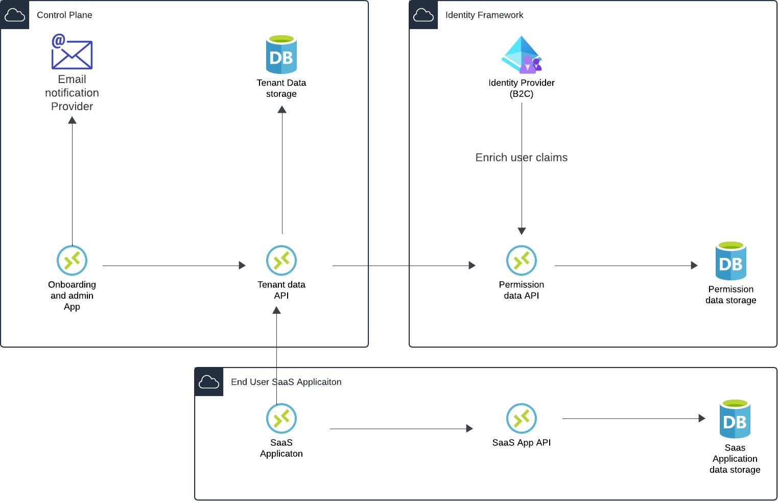

**MOTIVATION**

**Accessibility:** By offering the Image Editor and Background Remover as a SaaS solution, users can access the tools from anywhere with an internet connection. This accessibility eliminates the need for users to install and maintain software locally on their devices, making it convenient for individuals and businesses alike.

**Cost-effectiveness:** SaaS solutions typically operate on a subscription-based model, allowing users to pay for only the services they need and use. This pay-as-you-go model can be more cost-effective for users compared to purchasing and maintaining standalone software licenses, particularly for businesses with fluctuating demand or budgets.

**Scalability:** SaaS solutions can easily scale to accommodate varying levels of demand and user base sizes. As the number of users or the volume of image editing tasks increases, the infrastructure supporting the SaaS application can be scaled up accordingly without requiring significant upfront investment in hardware or software.

**Collaboration and sharing:** SaaS-based Image Editor and Background Remover solutions can facilitate collaboration among users by allowing them to share images, collaborate on editing projects in real-time, and provide feedback seamlessly. This collaborative aspect is particularly beneficial for teams or organizations working on design or marketing projects.

**Continuous updates and improvements:** With a SaaS model, developers can roll out updates, patches, and new features to users seamlessly without disrupting their workflows. This ensures that users always have access to the latest tools, enhancements, and security fixes, providing a better overall user experience.

# Objectives

**User-Friendly Interface:** One of the primary objectives is to design a user-friendly interface that caters to users of all skill levels. The interface should be intuitive, visually appealing, and easy to navigate, ensuring that even novice users can perform complex image editing tasks without extensive training or prior experience. Clear labeling, tooltips, and contextual help should guide users through the editing process, while intuitive drag-and-drop functionality and interactive previews enhance the user experience. By prioritizing usability and accessibility, the SaaS solution aims to empower users to create professional-quality images with minimal effort and frustration.

**Advanced Editing Capabilities**: Another key objective is to provide advanced editing capabilities that enable users to achieve precise and professional results. This includes a comprehensive set of editing tools and features such as cropping, resizing, retouching, color correction, filters, text overlays, and graphics manipulation. Additionally, the background remover tool should leverage cutting-edge algorithms to accurately isolate subjects from their backgrounds, allowing users to create stunning compositions and remove distractions with ease. By offering a wide range of editing options and functionalities, the SaaS solution aims to meet the diverse needs of users across different industries and creative disciplines.

**Scalability:** Scalability is a crucial objective to ensure that the SaaS solution can accommodate a growing user base and handle increasing demand for image editing services. This involves designing a scalable infrastructure that can dynamically allocate resources based on workload fluctuations and user activity levels. Implementing cloud-based technologies and leveraging elastic scaling mechanisms allows the SaaS solution to scale both vertically and horizontally to meet evolving performance requirements. By ensuring scalability, the solution can maintain high availability, reliability, and responsiveness, even during peak usage periods, while optimizing resource utilization and minimizing operational costs for the service provider.

# IMPLEMENTATION DETAILS

Application Setup:

The video guides viewers on setting up a new folder for the application and utilizing Next.js as the selected web framework.

It illustrates the installation of Shaten for creating a component library, crucial for designing various interface components.

Layout and Styling Customization:

Details are provided on defining the application title and description to enhance user understanding.

The incorporation of IBM Plex Sans font for a unique typography style is explained, helping to establish a distinct visual identity.

Demonstrates the integration of Tailwind CSS for responsive and customizable design elements, enhancing the user experience.

Database Integration and Management:

Usage of MongoDB Atlas collections for efficient database management, ensuring smooth data storage and retrieval processes.

Configuration of user management functionalities through Clerk, enabling seamless user authentication and access control.

Credit System Implementation:

Explanation of the credit system for user interactions within the application, showcasing how users can earn and utilize credits for specific actions.

Illustrates the process of insufficient credits, guiding users on how to purchase additional credits via integration with Stripe payment gateway.

User Authentication with Clerk:

Walkthrough of user authentication processes, including signup and signin functionalities, facilitated by Clerk's user management capabilities.

Demonstrates user interactions based on available credits, providing a practical and secure authentication experience for users.

AI Image Transformation Features:

Introduces AI-powered image transformation tools, including generative fill, object removal, recoloring, and background removal functionalities for enhanced image editing.

Showcases the integration of Cloudinary for AI capabilities, highlighting the advanced image manipulation features available to users.

This detailed breakdown captures the core elements of the YouTube video, emphasizing the holistic approach to full-stack web application development, integration of AI tools, efficient user management, and interactive credit-based system implementation. It provides a comprehensive overview of the technical aspects involved in building and deploying a sophisticated AI SaaS platform using modern technologies and tools.

Workload distribution among members:

:

|  |  |  |  |
| --- | --- | --- | --- |
| Sr.  No | Member name | Tasks carried out | List of resources used/  technology used |
| 1) | Dhiraj Wadile | Backend | Clerk  Cloudinary  Stripe |
| 2) | Linisha Thakor | Frontend | ShadcnUI  Clerk  Nextjs |
| 3) | Vedant Solunke | Backend | MongoDB  Nextjs  Nodejs |

**Mention Visualization techniques used. (List functions used):** Operating system-level virtualization for an Image Editor and Background Remover platform is a strategic choice that leverages containerization technology to enhance the efficiency, scalability, and manageability of the application. By breaking down the application into microservices and packaging them into lightweight, isolated containers, organizations can achieve greater agility and flexibility in deploying and managing the software. Containers provide a portable and consistent runtime environment across different infrastructure platforms, enabling seamless deployment from development to production environments. This portability also facilitates easy scaling of the application to handle varying workloads and user demands, as containers can be quickly spun up or down based on resource requirements. Additionally, containerization improves resource efficiency by sharing the host operating system's kernel and reducing overhead compared to traditional virtual machines. Security is enhanced through container isolation and the implementation of security measures such as network segmentation and container image scanning. Furthermore, operating system-level virtualization aligns well with DevOps practices, enabling organizations to automate the deployment pipeline and accelerate the delivery of updates and new features to users. Overall, by adopting containerization for the Image Editor and Background Remover platform, organizations can streamline operations, improve scalability, and enhance security, ultimately delivering a more robust and efficient software solution.

# OUTPUT (screen shots)

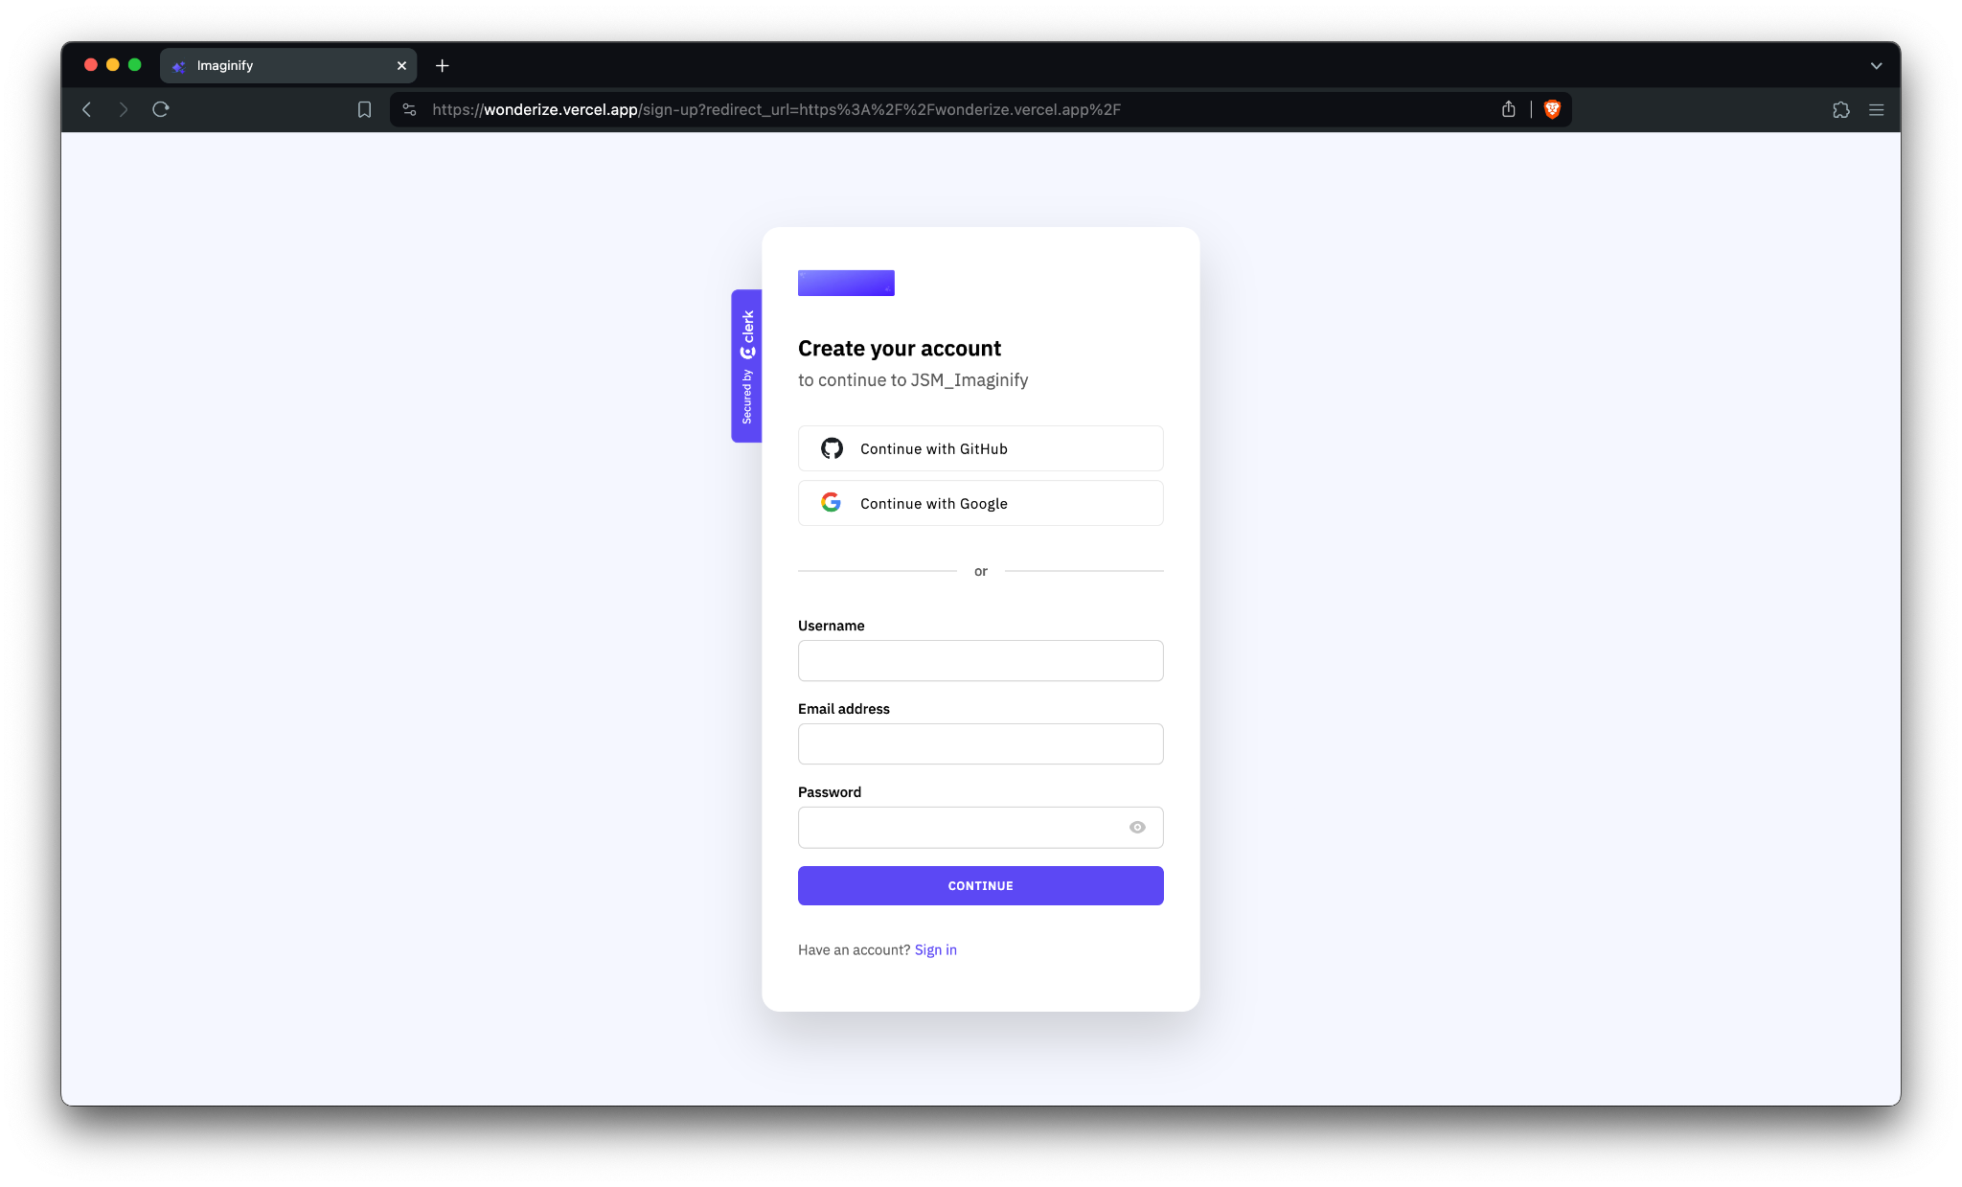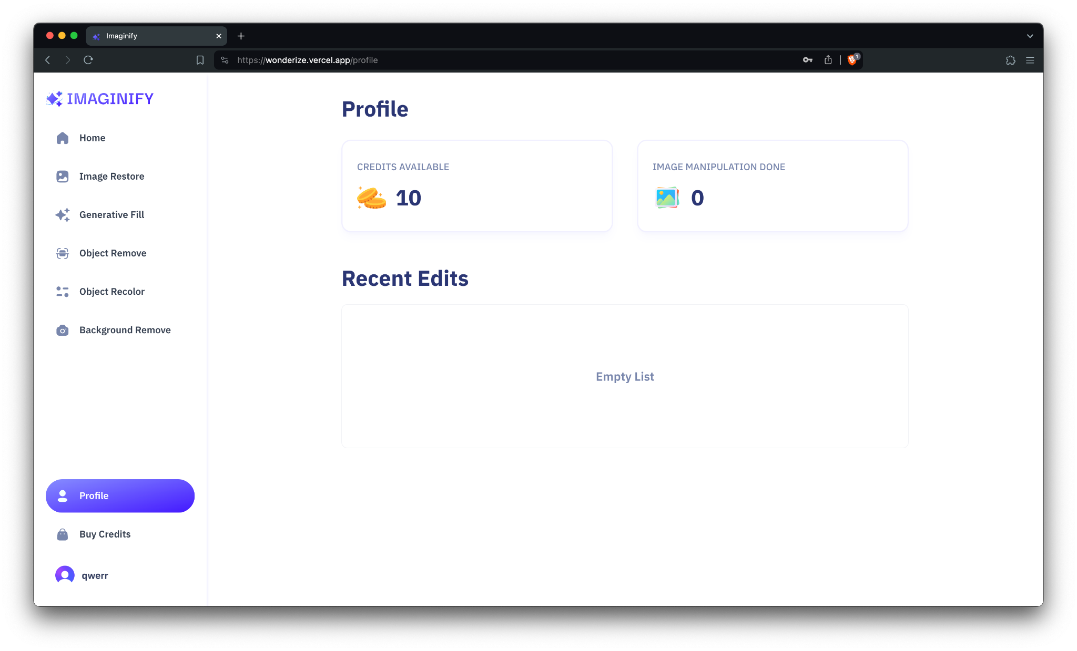Screenshots of output clearly showing above mentioned objectives are met.

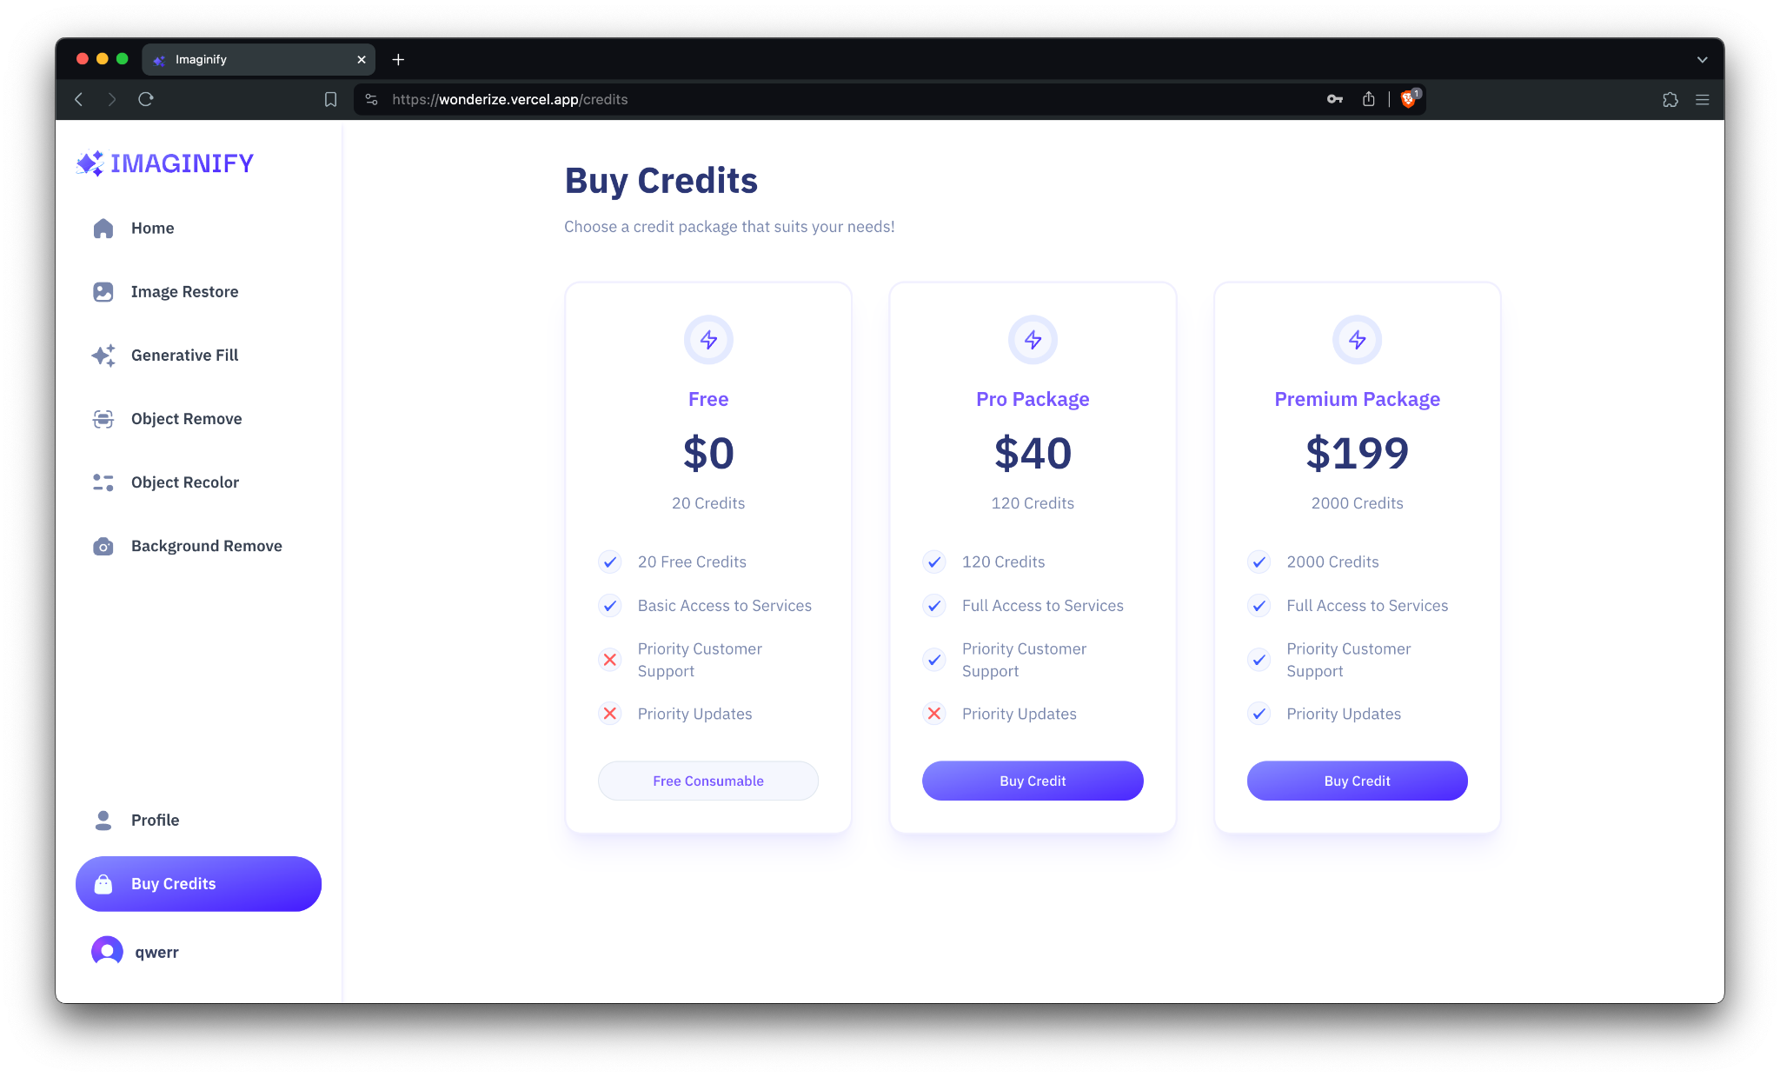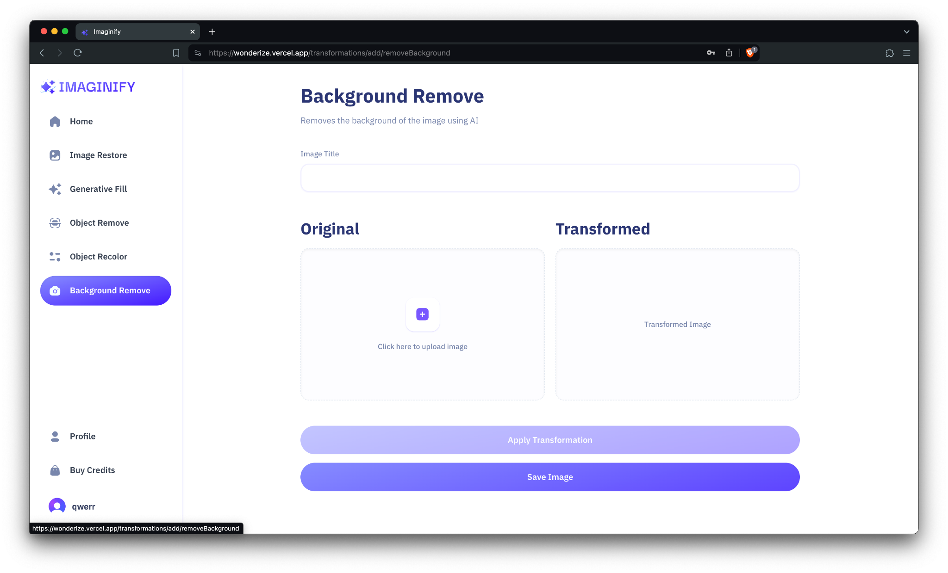

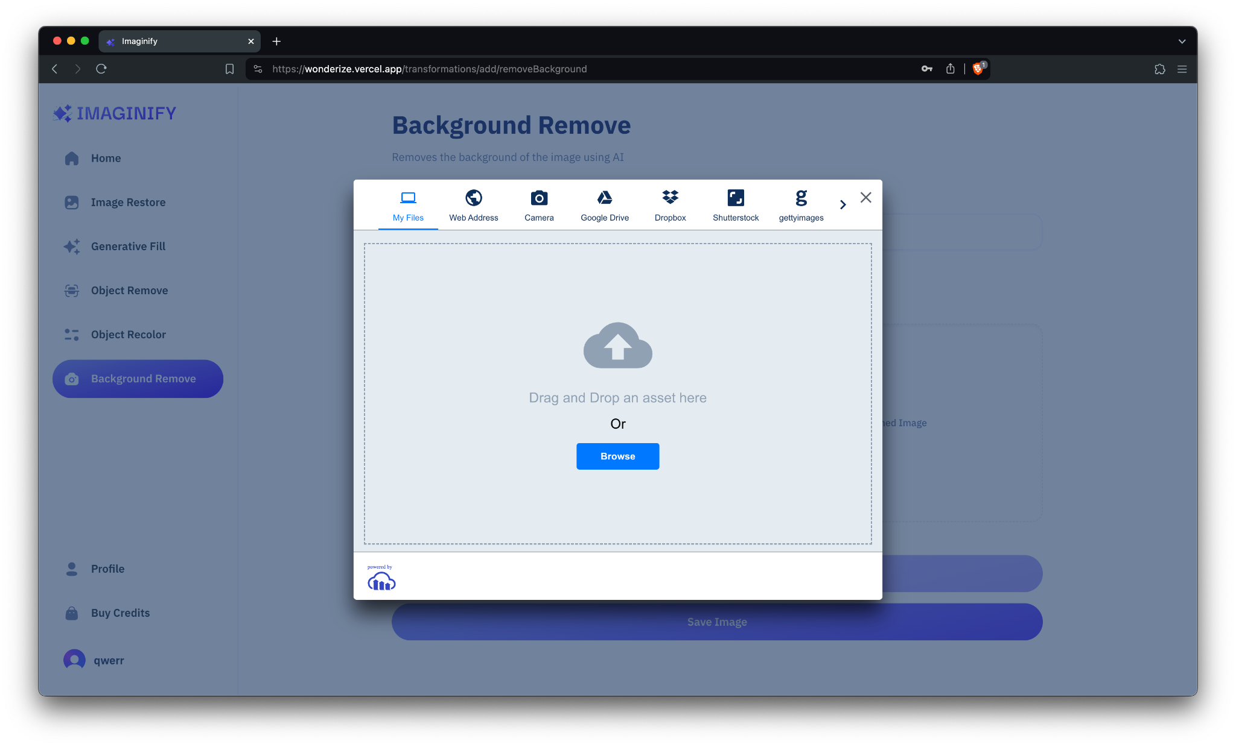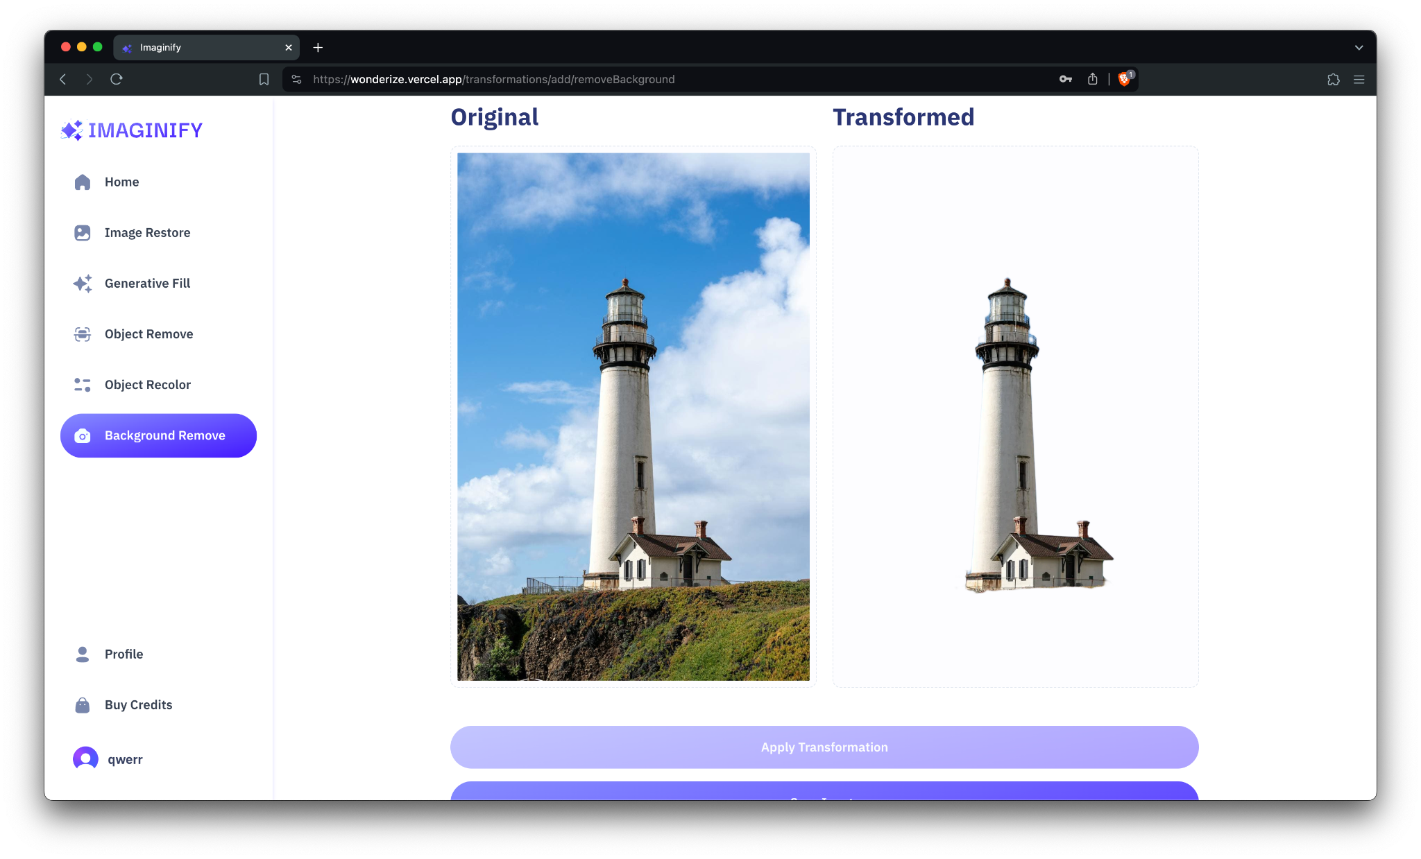

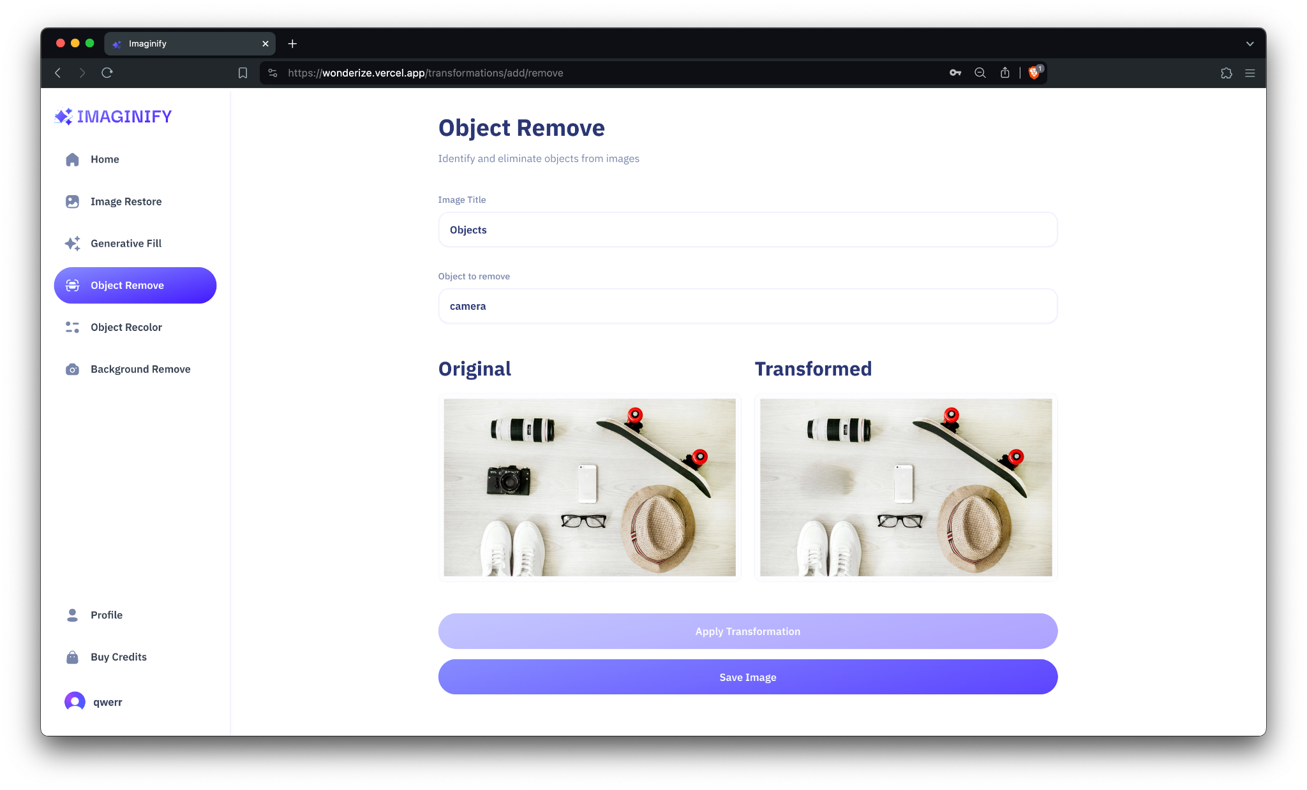

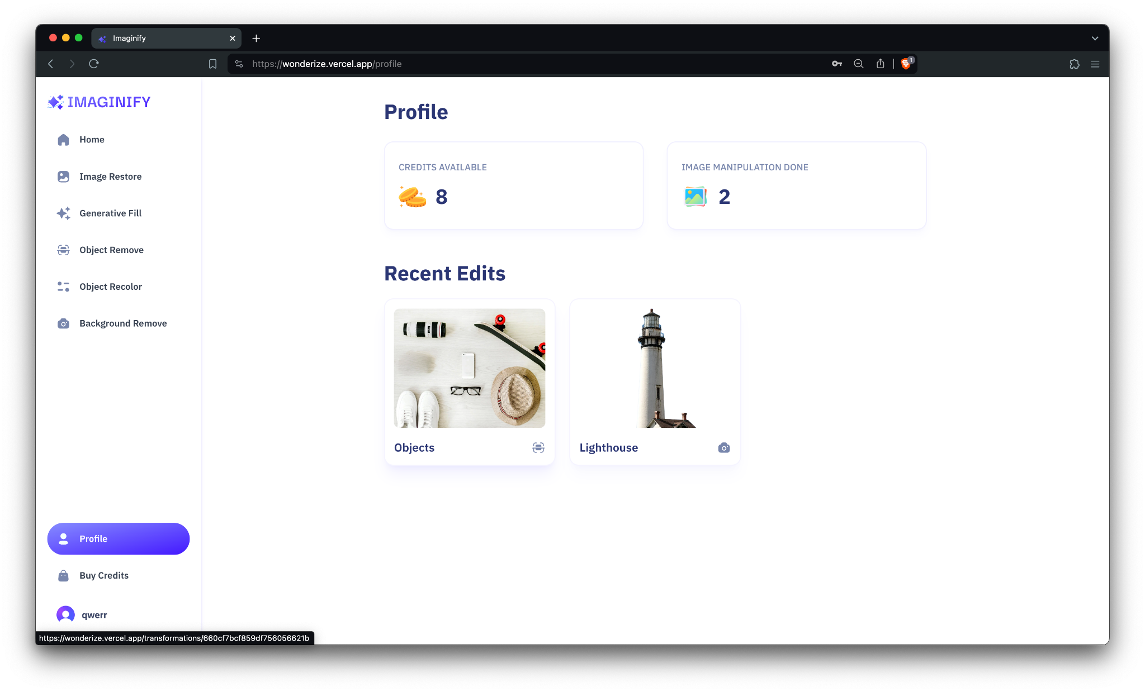

# CONCLUSION

The Image Editor and Background Remover project as a Software as a Service (SaaS) solution holds immense potential to revolutionize the way users edit images and remove backgrounds. By combining advanced editing capabilities with a user-friendly interface and scalable infrastructure, this innovative solution aims to empower users to create professional-quality images with ease and efficiency. Firstly, the project's emphasis on a user-friendly interface ensures that users of all skill levels can seamlessly navigate the editing tools and achieve their desired results. Intuitive design elements, interactive previews, and contextual help features guide users through the editing process, fostering a positive user experience and reducing the learning curve associated with traditional image editing software. Moreover, the project's focus on advanced editing capabilities ensures that users have access to a comprehensive set of tools and features to enhance their images. From basic editing functions like cropping and resizing to more advanced techniques such as color correction, retouching, and background removal, the SaaS solution provides users with the flexibility and versatility needed to unleash their creativity and achieve professional-grade results. Furthermore, the project's scalability ensures that the solution can adapt to the evolving needs and demands of users. By leveraging cloud-based technologies and elastic scaling mechanisms, the SaaS solution can dynamically allocate resources to handle fluctuations in workload and user activity levels, ensuring high availability, reliability, and responsiveness even during peak usage periods.

Overall, the Image Editor and Background Remover project as a SaaS solution represents a significant advancement in image editing technology. By offering a combination of user-friendly interface, advanced editing capabilities, and scalability, the solution empowers users to unleash their creativity, express their ideas, and bring their visions to life through stunning visual compositions. With its potential to streamline the image editing process and democratize access to professional-quality editing tools, this project has the power to transform the way users interact with and manipulate digital images in various industries and creative disciplines.

# REFERENCES

* https://nextjs.org/
* https://www.mongodb.com/docs/
* https://www.npmjs.com/package/@clerk/nextjs